

|  |
| --- |
| User Manual for Indent |
| REFERENCE: GW/ERP/USER MANUAL |
|  |
| **Genweb2 Ltd.** |
| **12-Dec-18** |

|  |
| --- |
|  |

# Document Information

|  |  |
| --- | --- |
| Document Name | User manual for Indent |
| Document Author | Rashedul Alam |
| Document Version | 1.0 |
| Release Date | 12th Dec, 2018 |

|  |  |
| --- | --- |
| Review by | Md. Mahfuzur Rahman |
| Review Date | 13th Dec, 2018 |
| Approved By |  |
| Approval Date |  |

# Document History

|  |  |  |  |  |  |
| --- | --- | --- | --- | --- | --- |
| A=Added, M=Modified, D=Delete | | | | | |
| **Version No** | **Date** | **Section No** | **A/M/D** | **Description of Change** | **Author** |
| 1.0 | 12-Dec-2018 |  | A | Initial | Rashedul Alam |

Contents

A. Document Information 2

B. Document History 2

Contents 3

1. Introduction 4

1.1 Purpose of User manual 4

2. Indents 4

2.1 Indent raise by employee 5

2.2. Indents approval 6

2.2.1 Indents approval by Indent approver/Head of Department 6

3. View Indent status 9

3.1 View Indent status by Employee 9

4. View Log indent 10

4.1 View Log Indent by Employee 10

# 1. **Introduction**

The purposes of this User manual is to clearly identify the customer requirements and provide a detailed document. The customer will read this document and get a clear view indent process.

## Purpose of User manual

The purpose of this User Manual is to clearly identify the customer requirements and provide a detailed document. The customer will read this document and get a clear view of Indent.

# 2. Indents

Each and every Employee will able to raise indent and Indent approver will approve indents.

If available stock then indent will go for issue indent .If stock not available then will go for Issue PR and it’s another process.

**Indent no:** System will generate auto a unique no after indent creation. Here will first operating number then Year then unique a number.

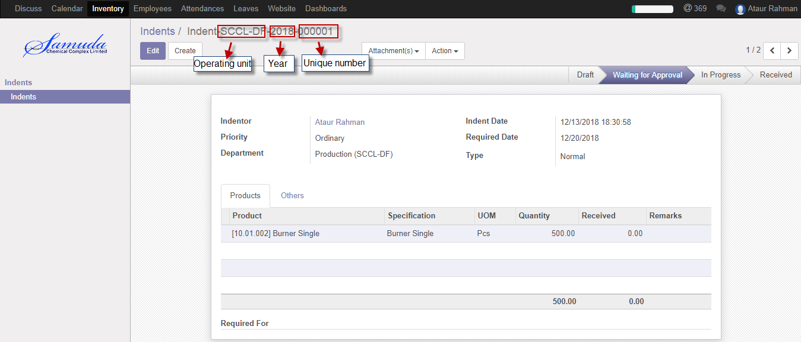

Figure: Indent number

**Indent Search:** Employee is capable to Search indent with variant combination like; with indent no, Company, Department wise etc. 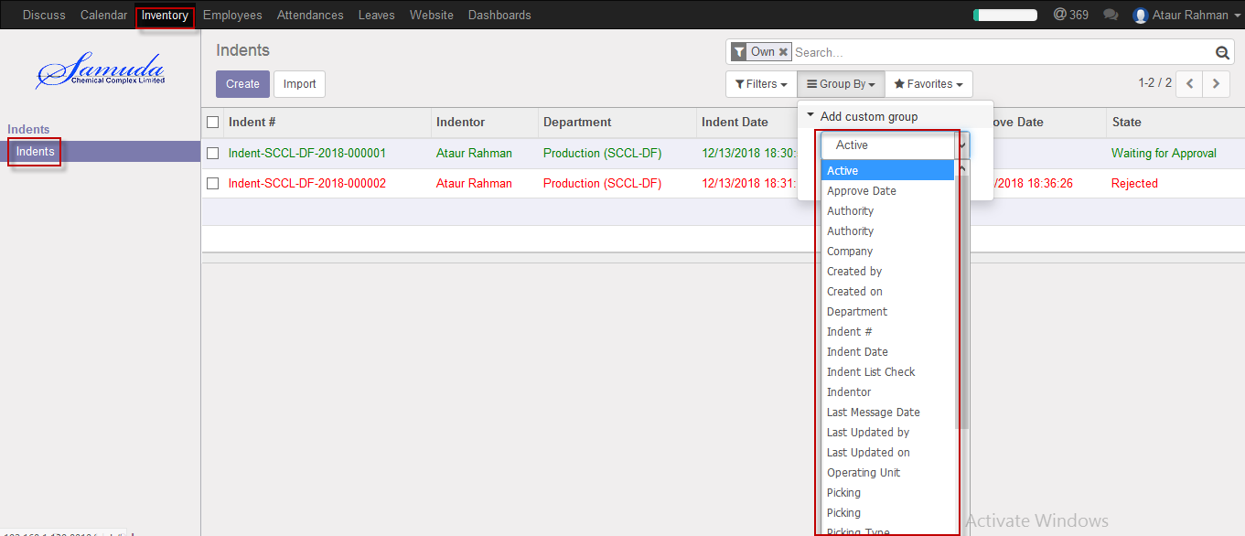 Figure: Indent Search

## 2.1 Indent raise by employee

Indent will be created/Edit by employee

Employee can raise Indent using the menu **Inventory ‣ indents** and click **Create.**

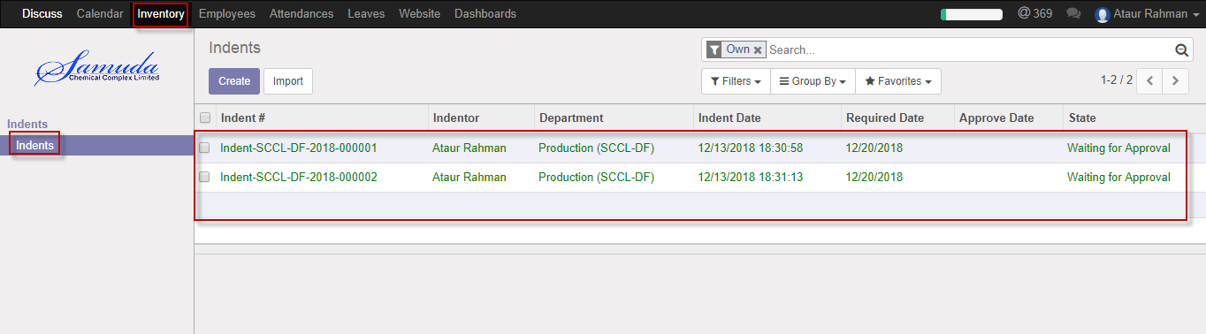

Figure: Indents List view

We need to set the following:-

**Priority**: Select priority.

**Required date:** Select required date.

**Type:** Select type.

**Product:** Select product.

**Quantity:** Select qty.

**Department:** Department is user department will come auto default.

**Required For:** Enter required for if user needs.

After entering all information click **Save & Confirm**.

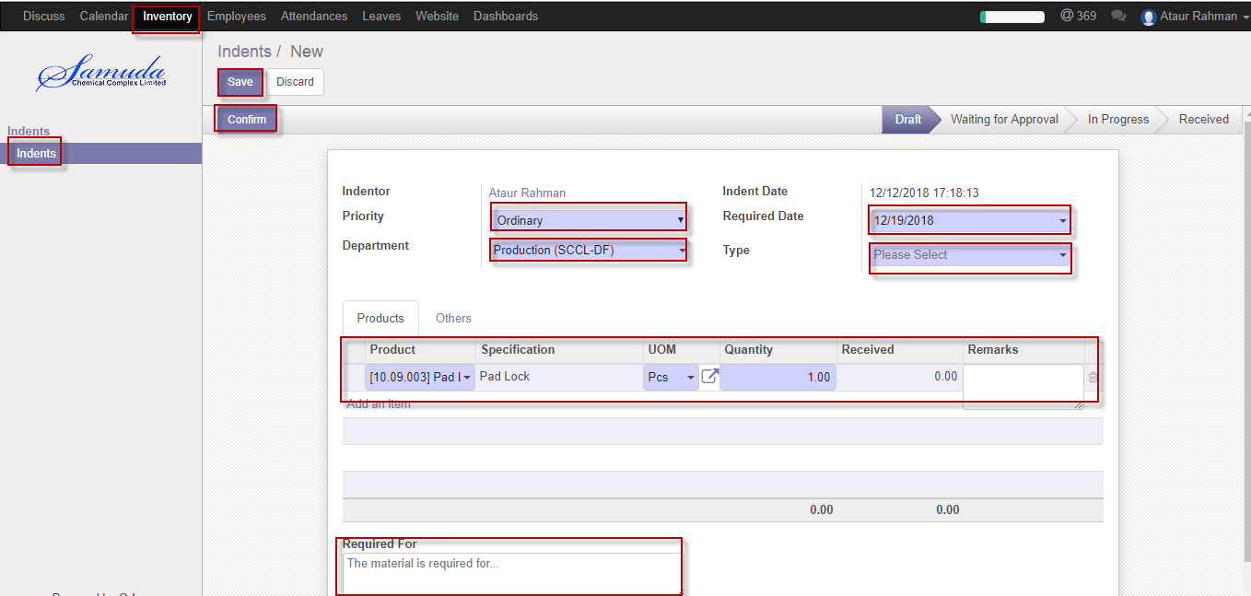

Figure: Create Indents

# 2.2. Indents approval

Each and every Employee will raise indent and Indent approver will approve indents.

## 2.2.1 Indents approval by Indent approver/Head of Department

After raise the Indents, Indents approver/Head of department will get the notification. He/she can update before approve if require.

To see the Pending indents use the menu **Inventory ‣ Indents>>Indents waiting for approval**

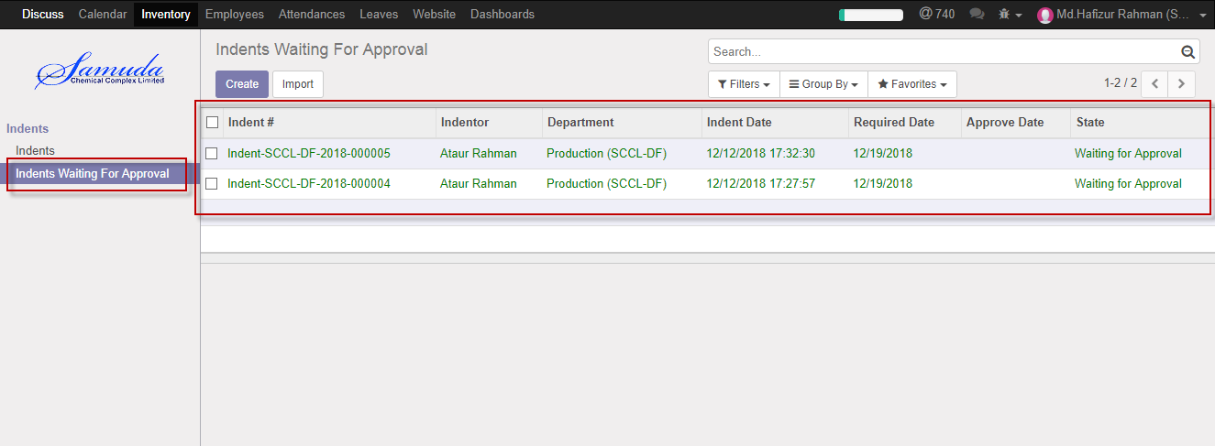

Figure: Indents waiting for approval list view

Indent approver/Head of Department can approve. Select an indent from list then click on **Approve** button 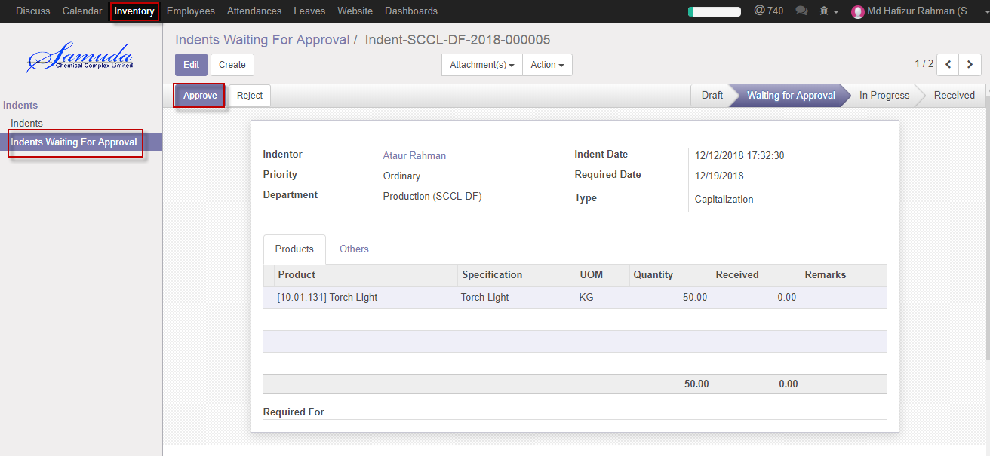

Figure: Indents approved

Indents approver is capable to reject indent by click **Reject** Button.

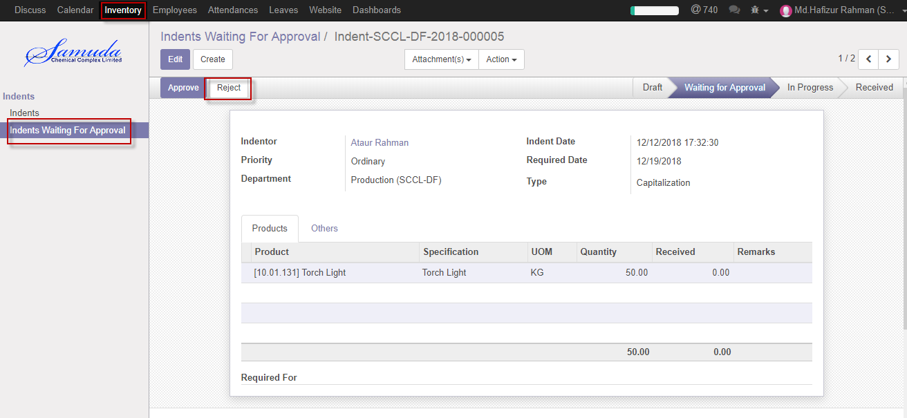

Figure: Indents reject

Reject indent state view:

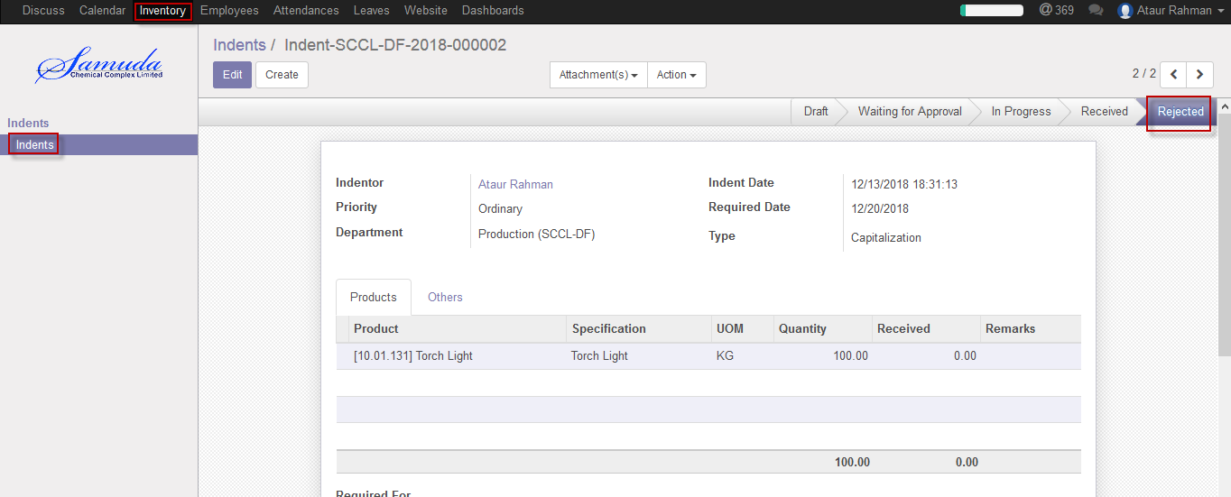

Figure: Indents reject state

# 3. View Indent status

Employee will go indent View state to understand indent Overall status.

## 3.1 View Indent status by Employee

Indent status will be viewed by Employee.

Employee can View Indent status using the menu **Inventory ‣ indents** >>click **Indent** from list.

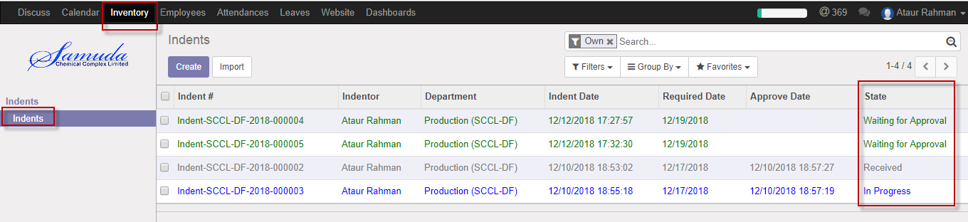

Figure: Indent list view

We need to View the following:-

**Quantity:** Quantity is represent indent qty, which is employee required qty.

**Received quantity:** Receive qty is represent issued qty against indent. Employee will get clear view to see receive qty that How many issued qty against indent.

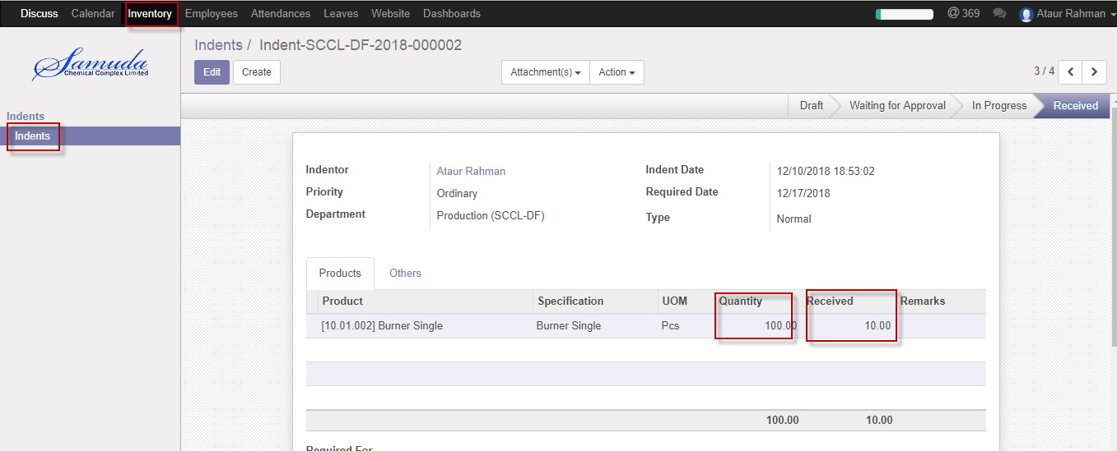

Figure: Indent details view (After issue)

# 4. View Log indent

Employee is able to view log status with time.

## 4.1 View Log Indent by Employee

Indent Log will be viewed by Employee.

Employee can View Indent Log using the menu **Inventory ‣ indents** >>click **Indent** from list then view logs

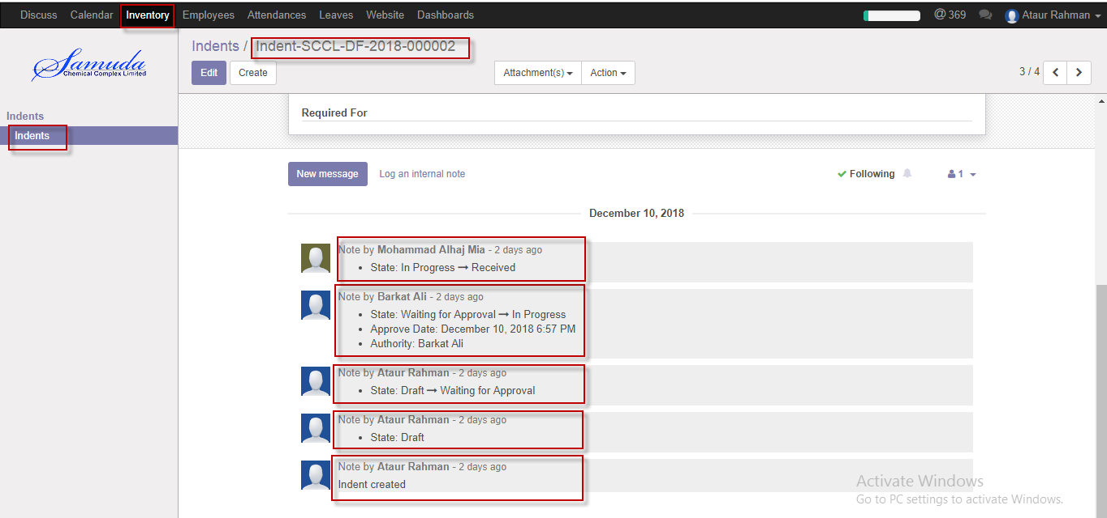

Figure: Indent Log view

Following logs are viewed by Employee:-

**Ataur Rahman:** Indent Created.

**Barkat Ali:** Approved indent.

**Mohammad Alhaj Mia:** Issue indent.